File Name: config.php

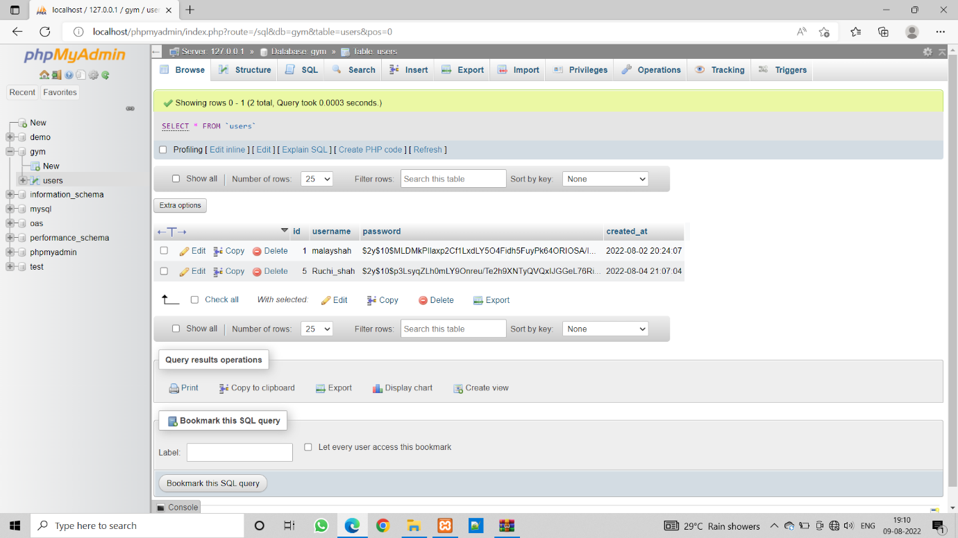

|  |
| --- |
| <?php  define('DB_SERVER', 'localhost');  define('DB_USERNAME', 'root');  define('DB_PASSWORD', '');  define('DB_NAME', 'gym');    $link = mysqli_connect(DB_SERVER, DB_USERNAME, DB_PASSWORD, DB_NAME);    if($link === false)  {  die("ERROR: Could not connect. " . mysqli_connect_error());  }  ?> |

Code:

File Name: login.php

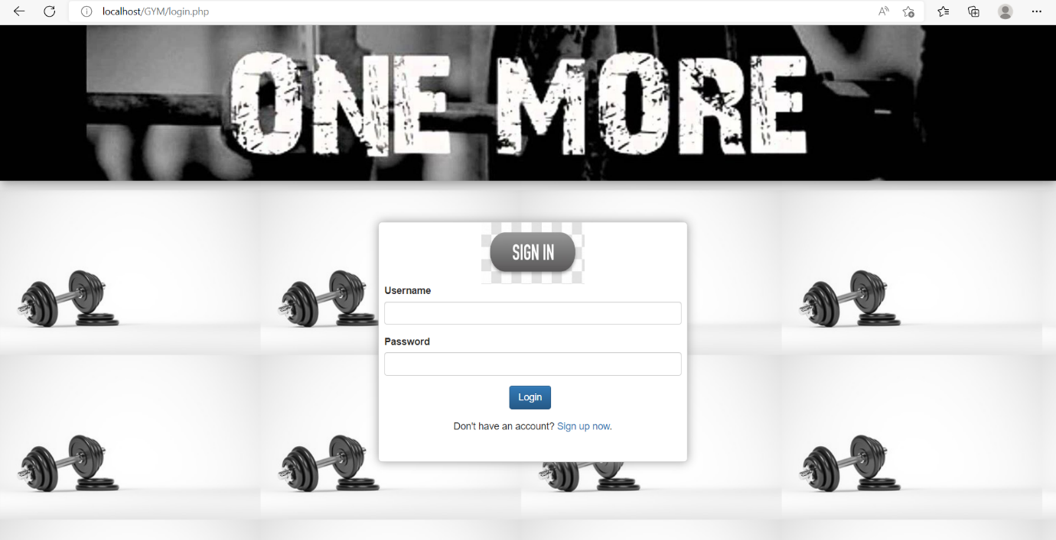

Code:

|  |
| --- |
| <?php  session_start();    if(isset($_SESSION["loggedin"]) && $_SESSION["loggedin"] === true)  {  header("location: welcome.php");  exit;  }  require_once "config.php";    $username = $password = "";  $username_err = $password_err = $login_err = "";    if($_SERVER["REQUEST_METHOD"] == "POST")  {    if(empty(trim($_POST["username"])))  {  $username_err = "Please enter username.";  } else  {  $username = trim($_POST["username"]);  }    if(empty(trim($_POST["password"])))  {  $password_err = "Please enter your password.";  }  else  {  $password = trim($_POST["password"]);  }    if(empty($username_err) && empty($password_err))  {  $sql = "SELECT id, username, password FROM users WHERE username = ?";    if($stmt = mysqli_prepare($link, $sql))  {  mysqli_stmt_bind_param($stmt, "s", $param_username);    $param_username = $username;    if(mysqli_stmt_execute($stmt))  {  mysqli_stmt_store_result($stmt);    if(mysqli_stmt_num_rows($stmt) == 1)  {  mysqli_stmt_bind_result($stmt, $id, $username, $hashed_password);    if(mysqli_stmt_fetch($stmt))  {  if(password_verify($password, $hashed_password)){  session_start();    $_SESSION["loggedin"] = true;  $_SESSION["id"] = $id;  $_SESSION["username"] = $username;    header("location: welcome.php");  }  else  {  $login_err = "Invalid username or password.";  }  }  }  else  {  $login_err = "Invalid username or password.";  }  }  else  {  echo "Oops! Something went wrong. Please try again later.";  }  mysqli_stmt_close($stmt);  }  }    mysqli_close($link);  }  ?>  <html>  <head>  <meta http-equiv="Content-Type" content="text/html; charset=UTF-8">  <link rel="stylesheet" href="bootstrap/bootstrap.min.css">  <link rel="stylesheet" href="bootstrap/bootstrap-theme.min.css">  <script src="bootstrap/jquery.min.js"></script>  <script src="bootstrap/bootstrap.min.js"></script>  <style>  .body{  }    #dmain  {  box-shadow: 0px 0px 14px #999999;  border-radius:5px;  border-color: #d3d3d3;  border-width: 1px;  border-style: solid;  background-color:white;  width:450px;  height:350px;  margin-left: 550px;    }  #u_id  {  margin-left: 8px;  margin-right : 8px;  margin-up : 8px;  }  #u_ps  {  margin-left: 8px;  margin-right :8px;  }  #u_sub  {  margin-left: 190px;  margin-right: 8px;  }  #u_not  {  margin-left : 8px;  margin-right : 8px;  align : center;  }  #back  {  width:1000px;  height:100px;  }  </style>  </head>  <body style= "background-image:url('./images/gymmm.jpg');" >  <div class="container-fluid">  <div class="row">  <img src="images/onemore.jpg" width="100%" height = '30%' style="box-shadow: 1px 5px 14px #999999; "></img>  </div>  </div>  </div><br><br><br>  <div id = "dmain">  <center><img src="./images/singin.jpg" width="150px" height="90px" ></center>  <form action="<?php echo htmlspecialchars($_SERVER["PHP_SELF"]); ?>" method="post">  <div class="form-group" id = u_id>  <label>Username</label>  <input type="text" name="username" class="form-control <?php echo (!empty($username_err)) ? 'is-invalid' : ''; ?>" value="<?php echo $username; ?>">  <span class="invalid-feedback"><?php echo $username_err; ?></span>  </div>  <div class="form-group" id = u_ps>  <label>Password</label>  <input type="password" name="password" class="form-control <?php echo (!empty($password_err)) ? 'is-invalid' : ''; ?>">  <span class="invalid-feedback"><?php echo $password_err; ?></span>  </div>  <div class="form-group" id = u_sub>  <input type="submit" class="btn btn-primary" value="Login">  </div>  <div class = "form-group" id = u_not>  <p align = "center">Don't have an account? <a href="resig.php">Sign up now</a>.</p>  </div>  </form>  </div>  </div>  </body>  </html> |

File Name: resig.php

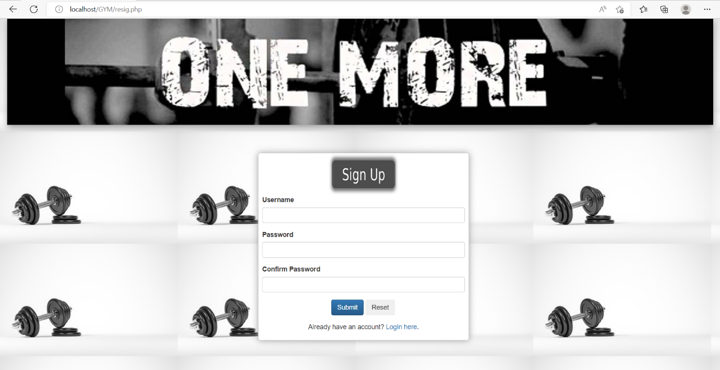

Code:

|  |
| --- |
| <?php  require_once "config.php";  $username = $password = $confirm_password = "";  $username_err = $password_err = $confirm_password_err = "";    if($_SERVER["REQUEST_METHOD"] == "POST")  {      if(empty(trim($_POST["username"])))  {  $username_err = "Please enter a username.";  }  elseif(!preg_match('/^[a-zA-Z0-9_]+$/', trim($_POST["username"])))  {  $username_err = "Username can only contain letters, numbers, and underscores.";  }  else  {    $sql = "SELECT id FROM users WHERE username = ?";    if($stmt = mysqli_prepare($link, $sql))  {    mysqli_stmt_bind_param($stmt, "s", $param_username);      $param_username = trim($_POST["username"]);      if(mysqli_stmt_execute($stmt))  {    mysqli_stmt_store_result($stmt); /* store result */    if(mysqli_stmt_num_rows($stmt) == 1)  {  $username_err = "This username is already taken.";  }  else  {  $username = trim($_POST["username"]);  }  }  else  {  echo "Oops! Something went wrong. Please try again later.";  }  mysqli_stmt_close($stmt);  }  }      if(empty(trim($_POST["password"])))  {  $password_err = "Please enter a password.";  }  elseif(strlen(trim($_POST["password"])) < 6)  {  $password_err = "Password must have atleast 6 characters.";  }  else  {  $password = trim($_POST["password"]);  }    if(empty(trim($_POST["confirm_password"])))  {  $confirm_password_err = "Please confirm password.";  }  else  {  $confirm_password = trim($_POST["confirm_password"]);  if(empty($password_err) && ($password != $confirm_password))  {  $confirm_password_err = "Password did not match.";  }  }      if(empty($username_err) && empty($password_err) && empty($confirm_password_err))  {    $sql = "INSERT INTO users (username, password) VALUES (?, ?)";    if($stmt = mysqli_prepare($link, $sql))  {    mysqli_stmt_bind_param($stmt, "ss", $param_username, $param_password);    $param_username = $username;  $param_password = password_hash($password, PASSWORD_DEFAULT);    if(mysqli_stmt_execute($stmt))  {  header("location: login.php");  } else  {  echo "Oops! Something went wrong. Please try again later.";  }  mysqli_stmt_close($stmt);  }  }    mysqli_close($link);  }  ?>  <html>  <head>  <meta http-equiv="Content-Type" content="text/html; charset=UTF-8">  <title></title>  <link rel="stylesheet" href="bootstrap/bootstrap.min.css">  <link rel="stylesheet" href="bootstrap/bootstrap-theme.min.css">  <script src="bootstrap/jquery.min.js"></script>  <script src="bootstrap/bootstrap.min.js"></script>  <style type="text/css">  .inpterr  {  border: 1px solid red;  background: #FFCECE;  }    .inpterrc  {  border: 1px solid black;  background: white;  }  #dmain  {  box-shadow: 0px 0px 14px #999999;  border-radius:5px;  border-color: #d3d3d3;  border-width: 1px;  border-style: solid;  background-color:white;  width:450px;  height:400px;  margin-left: 550px;    }  #r_id  {  margin-left: 8px;  margin-right : 8px;  margin-up : 8px;  }  #r_pass  {  margin-left: 8px;  margin-right :8px;  }  #r_cpass  {  margin-left: 8px;  margin-right: 8px;  }  #r_btn  {  margin-left: 155px;  margin-right: 8px;  }  #r_not  {  margin-left : 8px;  margin-right : 8px;  align : center;  }  </style>  </head>  <body style= "background-image:url('./images/gymmm.jpg');">  <div class="container-fluid">  <div class="row">  <div class="col-sm-12">  <img src="images/onemore.jpg" width="100%" height = '30%' style="box-shadow: 1px 5px 14px #999999; "></img>  </div>  </div>  </div><br><br><br>  <div id="dmain">  <center><img src="./images/signup.jpg" width="150px" height="90px" ></center>  <form action="<?php echo htmlspecialchars($_SERVER["PHP_SELF"]); ?>" method="post">    <div class="form-group" id = r_id>  <label>Username</label>  <input type="text" name="username" class="form-control <?php echo (!empty($username_err)) ? 'is-invalid' : ''; ?>" value="<?php echo $username; ?>">  <span class="invalid-feedback"><?php echo $username_err; ?></span>  </div>  <div class="form-group" id = r_pass>  <label>Password</label>  <input type="password" name="password" class="form-control <?php echo (!empty($password_err)) ? 'is-invalid' : ''; ?>" value="<?php echo $password; ?>">  <span class="invalid-feedback"><?php echo $password_err; ?></span>  </div>  <div class="form-group" id = r_cpass>  <label>Confirm Password</label>  <input type="password" name="confirm_password" class="form-control <?php echo (!empty($confirm_password_err)) ? 'is-invalid' : ''; ?>" value="<?php echo $confirm_password; ?>">  <span class="invalid-feedback"><?php echo $confirm_password_err; ?></span>  </div>  <div class="form-group" id = r_btn>  <input type="submit" class="btn btn-primary" value="Submit">  <input type="reset" class="btn btn-secondary ml-2" value="Reset">  </div>  <div class = "form-group" id = r_not>  <p align = "center">Already have an account? <a href="login.php">Login here</a>.</p>  </div>  </form>  </div>  </form>  </body>  </html> |

File Name: welcome.php

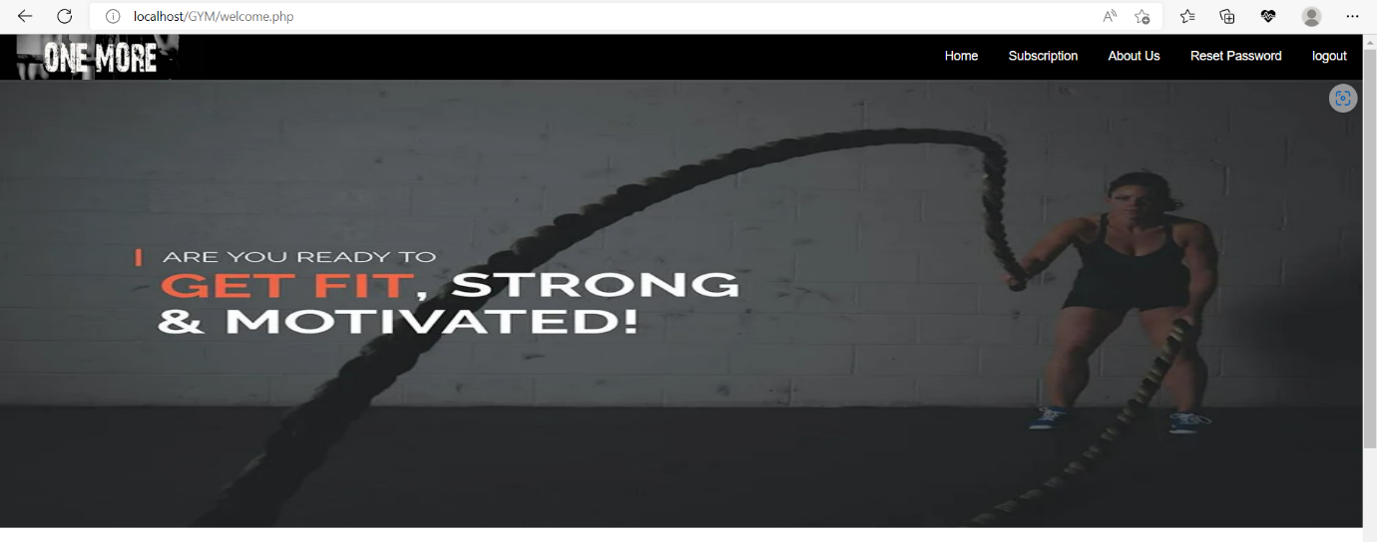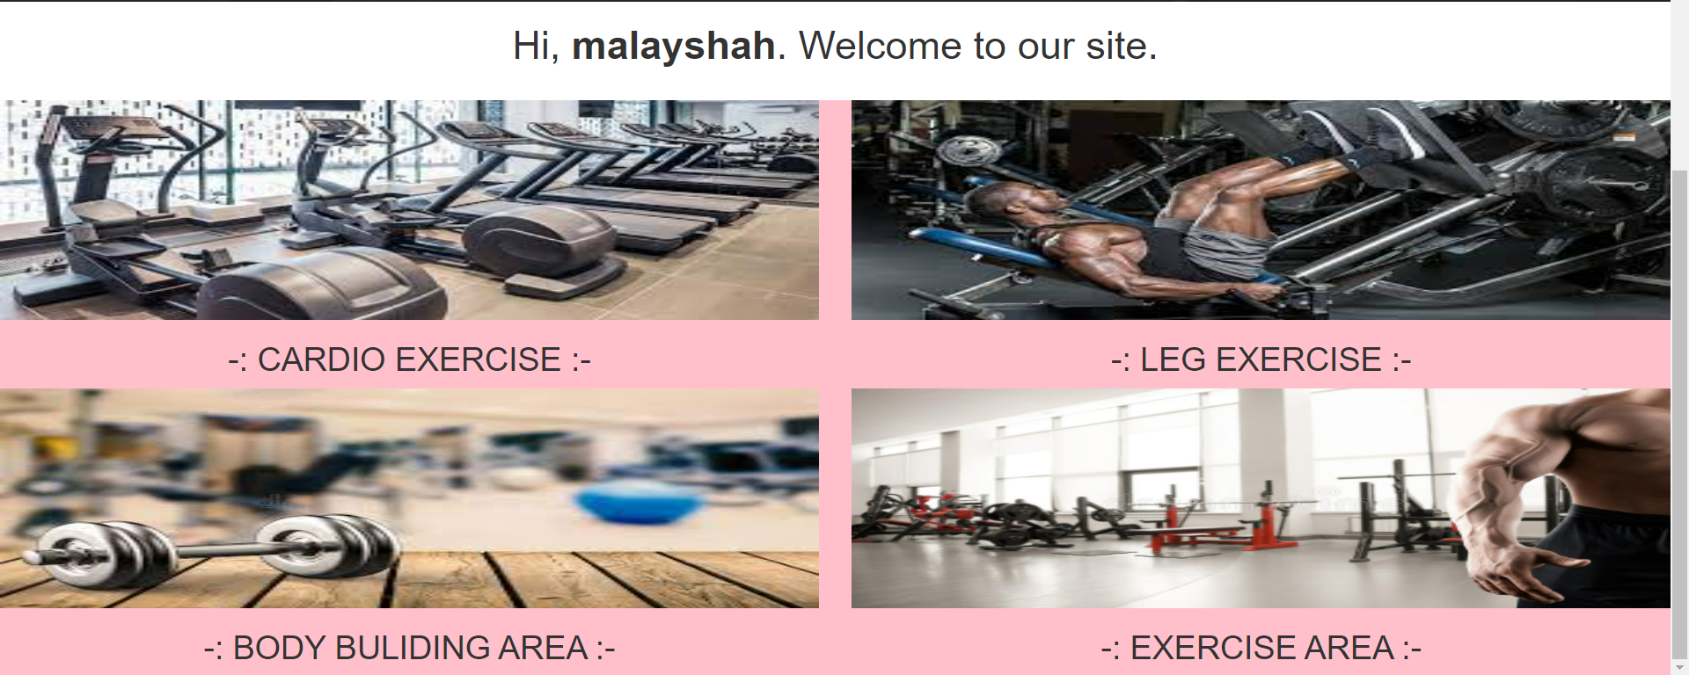

Code:

|  |
| --- |
| <?php  session_start();  if(!isset($_SESSION["loggedin"]) || $_SESSION["loggedin"] !== true)  {  header("location: login.php");  exit;  }  ?>  <!DOCTYPE html>  <html>  <head>  <meta http-equiv="Content-Type" content="text/html; charset=UTF-8">  <title></title>  <link rel="stylesheet" href="bootstrap/bootstrap.min.css">  <link rel="stylesheet" href="bootstrap/bootstrap-theme.min.css">  <script src="bootstrap/jquery.min.js"></script>  <script src="bootstrap/bootstrap.min.js"></script>  <style type="text/css">  <style>  #head  {  padding-top : 5px;    }  ul  {  list-style-type: none;  margin: 0;  padding: 0;  overflow: hidden;  background-color: black;  }  li  {  float: right;  border-right: 2px solid black;  }  li a  {  display: block;  color: white;  text-align: center;  padding: 14px 16px;  text-decoration: none;  }  li a:hover  {  background-color: black;  color : white;  }  .active  {  background-color: #04AA6D;  }  .gallery  {  margin: 5px;  border: 1px solid #ccc;  float: left;  width: 180px;  }  .gallery img  {  width: 100%;  height: auto;  }  .desc  {  padding: 15px;  text-align: center;  }  .backk  {  background-color : pink;  }  </style>  </head>  <body>    <ul>  <img src="images/onemore1.jpg" width="15%" height = '50px' style = "float : left"></img>  <li style = ><a href="logout.php">logout</a></li>  <li style = ><a href="reset-password.php">Reset Password</a></li>  <li style = ""><a href="about.php">About Us</a></li>  <li style = ""><a href="subs.php">Subscription </a></li>  <li style = ""><a href="welcome.php">Home</a></li>  </ul>    <div id = "wel">  <img src="images/gym10.jpg" width="100%" height = '500px' ></img>  <h1 align = "center">Hi, <b><?php echo htmlspecialchars($_SESSION["username"]); ?></b>. Welcome to our site.</h1>  </div><br>  <div class = "backk" >  <div class="row">  <div class="col-md-6" id = "bra">  <img src="images/cardio.jpg" width="100%" height = '200px' ></img>  <h2 align = "center">-: CARDIO EXERCISE :-</h2>  </div>  <div class="col-md-6" id = "bra">  <img src="images/leg.jpg" width="100%" height = '200px' ></img>  <h2 align = "center">-: LEG EXERCISE :-</h2>  </div>  </div>  <div class="row">  <div class="col-md-6" id = "bra">  <img src="images/gym4.jpg" width="100%" height = '200px' ></img>  <h2 align = "center">-: BODY BULIDING AREA :-</h2>  </div>  <div class="col-md-6" id = "bra">  <img src="images/gymm.jpg" width="100%" height = '200px' ></img>  <h2 align = "center">-: EXERCISE AREA :-</h2>  </div>  </div>  </div>  </body>  </html> |

File Name: subs.php

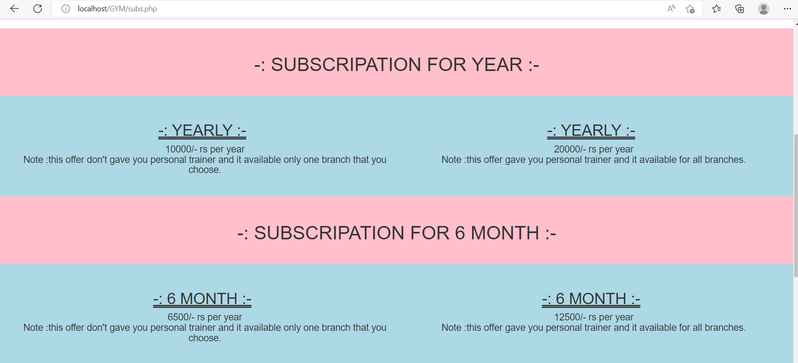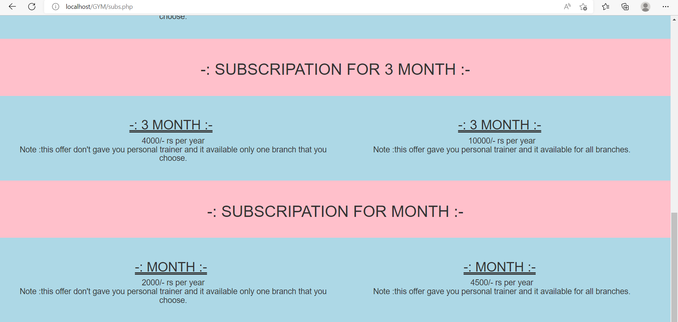

Code:

|  |
| --- |
| <?php  session_start();    if(!isset($_SESSION["loggedin"]) || $_SESSION["loggedin"] !== true)  {  header("location: login.php");  exit;  }  ?>  <!DOCTYPE html>  <html>  <head>  <meta http-equiv="Content-Type" content="text/html; charset=UTF-8">  <title></title>  <link rel="stylesheet" href="bootstrap/bootstrap.min.css">  <link rel="stylesheet" href="bootstrap/bootstrap-theme.min.css">  <script src="bootstrap/jquery.min.js"></script>  <script src="bootstrap/bootstrap.min.js"></script>  <style type="text/css">  <style>  #head  {  padding-top : 5px;    }  ul  {  list-style-type: none;  margin: 0;  padding: 0;  overflow: hidden;  background-color: black;  }  li  {  float: right;  border-right: 2px solid black;  }  li a  {  display: block;  color: white;  text-align: center;  padding: 14px 16px;  text-decoration: none;  }  li a:hover  {  background-color: black;  color : white;  }  #dmain  {  box-shadow: 0px 0px 14px #999999;  border-radius:5px;  border-color: #d3d3d3;  border-width: 1px;  border-style: solid;  background-color:white;  width:50%;  height:450px;  margin-left : 450px;  }  #u_id  {  margin-left: 8px;  margin-right : 8px;  margin-up : 8px;  }  #u_ps  {  margin-left: 8px;  margin-right :8px;  }  #u_sub  {  margin-left: 190px;  margin-right: 8px;  }  #u_not  {  margin-left : 8px;  margin-right : 8px;  align : center;  }  #back  {  width:1000px;  height:100px;  }  .column  {  float: left;  width: 90%;    height: 200px;  font-size : px;  }  .branch  {  background-color: white;  text-color : white;  padding: 30px;  text-align: center;  font-size: 35px;  background-color : pink;  }  .row  {  background-color: white;  text-color : white;  padding: 30px;  text-align: center;  font-size: 35px;  background-color : lightblue;  }    </style>  </head>  <body>    <ul>  <img src="images/onemore1.jpg" width="15%" height = '50px' style = "float : left"></img>  <li style = ><a href="logout.php">logout</a></li>  <li style = ><a href="reset-password.php">Reset Password</a></li>  <li style = ""><a href="about.php">About Us</a></li>  <li style = ""><a href="subs.php">Subscription </a></li>  <li style = ""><a href="welcome.php">Home</a></li>  </ul>    <div id = "wel">  <img src="images/gym10.jpg" width="100%" height = '500px' ></img>  </div><br>  <div class="branch">  <h1>-: SUBSCRIPATION FOR YEAR :-</h1>  </div>  <div class="row">  <div class="col-md-6" id = "bra">  <h2 align = "center" style = "text-decoration : underline double 2px">-: YEARLY :-</h2><h4 style = "padding-left : 10px" align = "center">10000/- rs per year<br>Note :this offer don't gave you personal trainer and it available only one branch that you choose.</h4>  </div>  <div class="col-md-6" id = "bra">  <h2 align = "center" style = "text-decoration : underline double 2px">-: YEARLY :-</h2><h4 style = "padding-left : 10px" align = "center">20000/- rs per year<br>Note :this offer gave you personal trainer and it available for all branches.</h4>  </div>  </div>  <div class="branch">  <h1>-: SUBSCRIPATION FOR 6 MONTH :-</h1>  </div>  <div class="row">  <div class="col-md-6" id = "bra">  <h2 align = "center" style = "text-decoration : underline double 2px">-: 6 MONTH :-</h2><h4 style = "padding-left : 10px" align = "center">6500/- rs per year<br>Note :this offer don't gave you personal trainer and it available only one branch that you choose.</h4>  </div>  <div class="col-md-6" id = "bra">  <h2 align = "center" style = "text-decoration : underline double 2px">-: 6 MONTH :-</h2><h4 style = "padding-left : 10px" align = "center">12500/- rs per year<br>Note :this offer gave you personal trainer and it available for all branches.</h4>  </div>  </div>  <div class="branch">  <h1>-: SUBSCRIPATION FOR 3 MONTH :-</h1>  </div>  <div class="row">  <div class="col-md-6" id = "bra">  <h2 align = "center" style = "text-decoration : underline double 2px">-: 3 MONTH :-</h2><h4 style = "padding-left : 10px" align = "center">4000/- rs per year<br>Note :this offer don't gave you personal trainer and it available only one branch that you choose.</h4>  </div>  <div class="col-md-6" id = "bra">  <h2 align = "center" style = "text-decoration : underline double 2px">-: 3 MONTH :-</h2><h4 style = "padding-left : 10px" align = "center">10000/- rs per year<br>Note :this offer gave you personal trainer and it available for all branches.</h4>  </div>  </div>  <div class="branch">  <h1>-: SUBSCRIPATION FOR MONTH :-</h1>  </div>  <div class="row">  <div class="col-md-6" id = "bra">  <h2 align = "center" style = "text-decoration : underline double 2px">-: MONTH :-</h2><h4 style = "padding-left : 10px" align = "center">2000/- rs per year<br>Note :this offer don't gave you personal trainer and it available only one branch that you choose.</h4>  </div>  <div class="col-md-6" id = "bra">  <h2 align = "center" style = "text-decoration : underline double 2px">-: MONTH :-</h2><h4 style = "padding-left : 10px" align = "center">4500/- rs per year<br>Note :this offer gave you personal trainer and it available for all branches.</h4>  </div>  </div>  <br><br>  </div>    </body>  </html> |

File Name: about.php

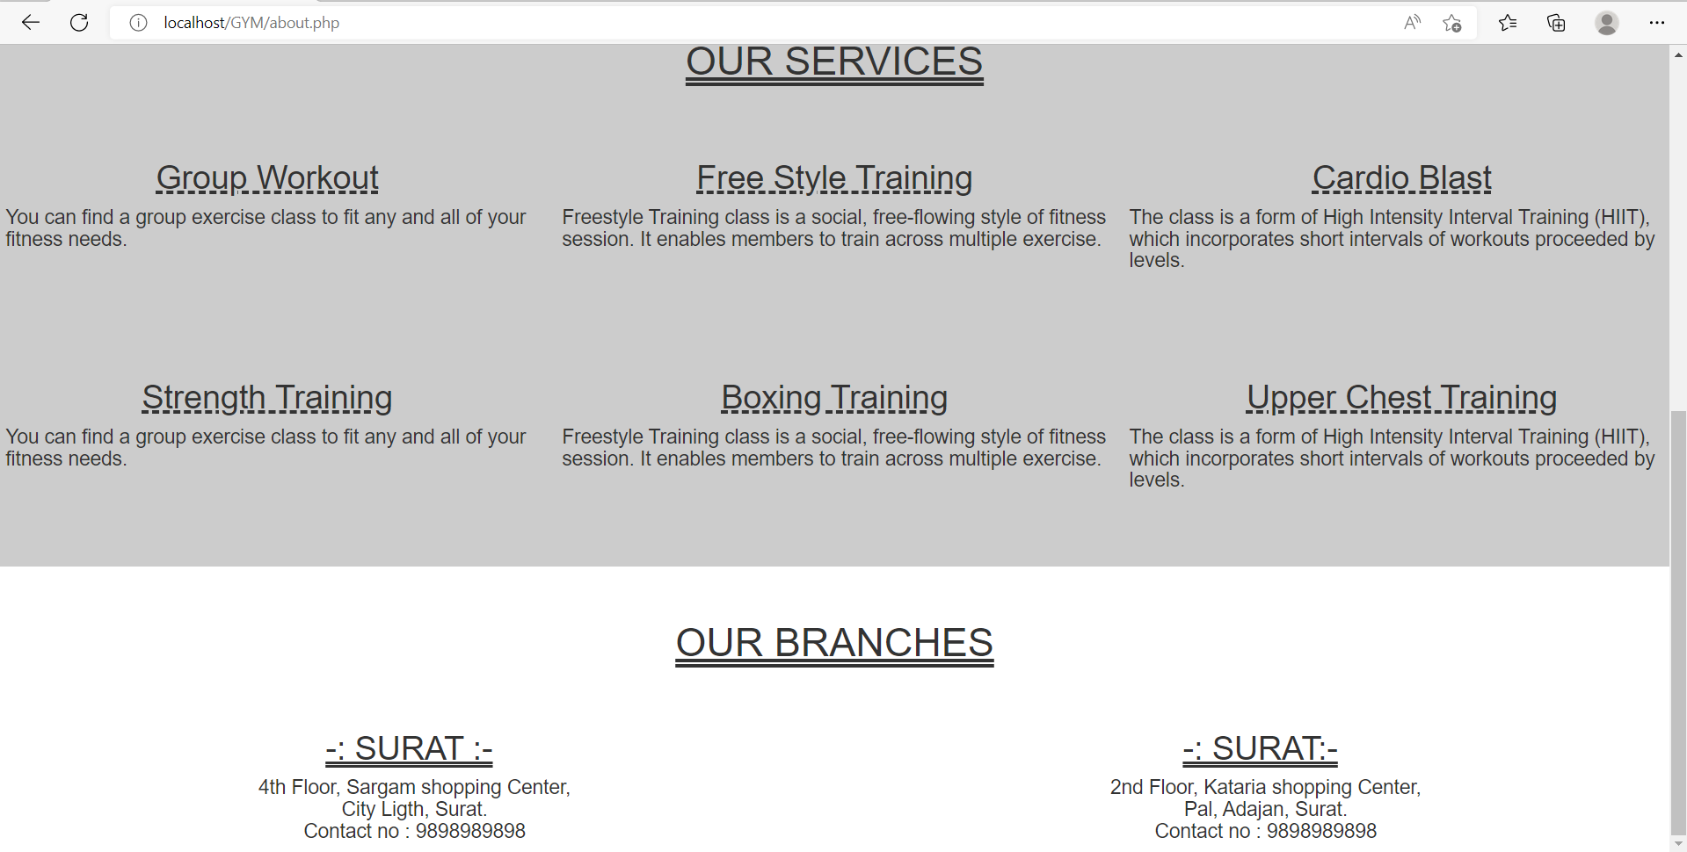

Code:

|  |
| --- |
| <?php  session_start();  if(!isset($_SESSION["loggedin"]) || $_SESSION["loggedin"] !== true)  {  header("location: login.php");  exit;  }  ?>  <!DOCTYPE html>  <html>  <head>  <meta http-equiv="Content-Type" content="text/html; charset=UTF-8">  <title></title>  <link rel="stylesheet" href="bootstrap/bootstrap.min.css">  <link rel="stylesheet" href="bootstrap/bootstrap-theme.min.css">  <script src="bootstrap/jquery.min.js"></script>  <script src="bootstrap/bootstrap.min.js"></script>  <style type="text/css">  <style>  .head  {  padding-top : 5px;    }  ul  {  list-style-type: none;  margin: 0;  padding: 0;  overflow: hidden;  background-color: black;  }  li  {  float: right;  border-right: 2px solid black;  }  li a  {  display: block;  color: white;  text-align: center;  padding: 14px 16px;  text-decoration: none;  }  li a:hover  {  background-color: black;  color : white;  }  .active  {  background-color: #04AA6D;  }  .service  {  text-align : center;  text-decoration: underline;  font-family: "Lucida Console", "Courier New", monospace;  }  .heading  {  background-color: #ccc;  text-color : white;  padding: 30px;  text-align: center;  font-size: 35px;  text-decoration : underline double;  }  #column  {  float: left;  width: 33.33%;  padding: 10px;  height: 200px;  font-size : px;  background-color : #ccc;  text-color : white;  }  .branch  {  background-color: white;  text-color : white;  padding: 30px;  text-align: center;  font-size: 35px;  text-decoration : underline double;  }  </style>  </head>  <body>    <ul>  <img src="images/onemore1.jpg" width="15%" height = '50px' style = "float : left"></img>  <li style = ><a href="logout.php">logout</a></li>  <li style = ><a href="reset-password.php">Reset Password</a></li>  <li style = ""><a href="about.php">About Us</a></li>  <li style = ""><a href="subs.php">Subscription </a></li>  <li style = ""><a href="welcome.php">Home</a></li>  </ul>    <div class= "wel">  <img src="images/gym10.jpg" width="100%" height = '500px' ></img>  </div>  <div class="heading">  <h1>OUR SERVICES</h1>  </div>  <div class="row">  <div class="col-sm-4" id = "column">  <h2 align = "center" style = "text-decoration : underline dashed 3px">Group Workout</h2><h4 style = "padding-left : 10px">You can find a group exercise class to fit any and all of your fitness needs.</h4>  </div>  <div class="col-sm-4" id = "column">  <h2 align = "center" style = "text-decoration : underline dashed 3px">Free Style Training</h2><h4 >Freestyle Training class is a social, free-flowing style of fitness session. It enables members to train across multiple exercise.</h4>  </div>  <div class="col-sm-4" id = "column">  <h2 align = "center" style = "text-decoration : underline dashed 3px">Cardio Blast</h2><h4 style = "padding-right : 10px">The class is a form of High Intensity Interval Training (HIIT), which incorporates short intervals of workouts proceeded by levels.</h4>  </div>  </div>  <div class="row">  <div class="col-sm-4" id = "column" >  <h2 align = "center" style = "text-decoration : underline dashed 3px">Strength Training</h2><h4 style = "padding-left : 10px">You can find a group exercise class to fit any and all of your fitness needs.</h4>  </div>  <div class="col-sm-4" id = "column" >  <h2 align = "center" style = "text-decoration : underline dashed 3px">Boxing Training</h2><h4>Freestyle Training class is a social, free-flowing style of fitness session. It enables members to train across multiple exercise.</h4>  </div>  <div class="col-sm-4" id = "column" >  <h2 align = "center" style = "text-decoration : underline dashed 3px">Upper Chest Training</h2><h4 style = "padding-right : 10px">The class is a form of High Intensity Interval Training (HIIT), which incorporates short intervals of workouts proceeded by levels.</h4>  </div>  </div>  <div class="branch">  <h1>OUR BRANCHES</h1>  </div>  <div class="row">  <div class="col-md-6" id = "bra">  <h2 align = "center" style = "text-decoration : underline double 2px">-: SURAT :-</h2><h4 style = "padding-left : 10px" align = "center">4th Floor, Sargam shopping Center,<br>City Ligth, Surat.<br> Contact no : 9898989898</h4>  </div>  <div class="col-md-6" id = "bra">  <h2 align = "center" style = "text-decoration : underline double 2px">-: SURAT:-</h2><h4 style = "padding-left : 10px" align = "center">2nd Floor, Kataria shopping Center,<br>Pal, Adajan, Surat.<br> Contact no : 9898989898</h4>  </div>  </div>  </body>  </html> |

File Name: Reset-password.php

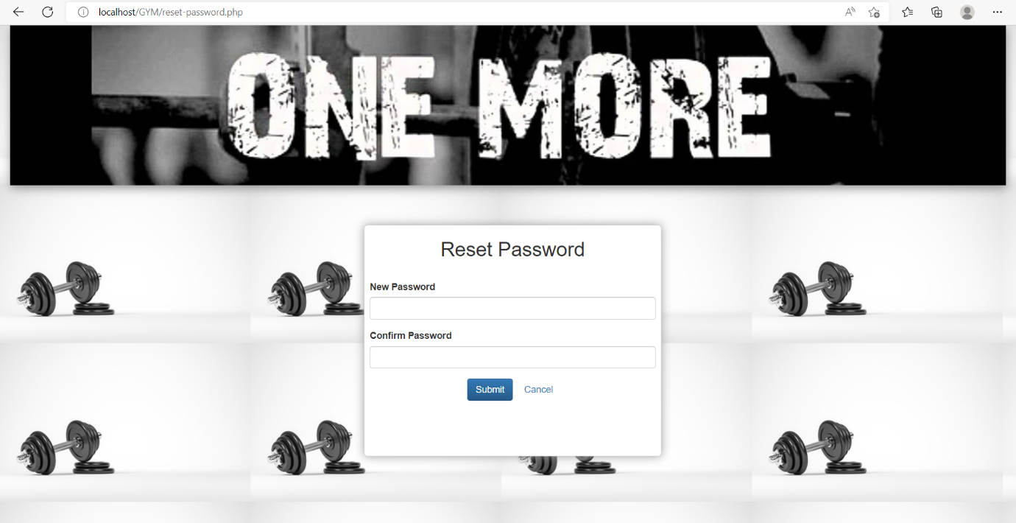

Code:

|  |
| --- |
| <?php  session_start();    if(!isset($_SESSION["loggedin"]) || $_SESSION["loggedin"] !== true)  {  header("location: login.php");  exit;  }    require_once "config.php";    $new_password = $confirm_password = "";  $new_password_err = $confirm_password_err = "";    if($_SERVER["REQUEST_METHOD"] == "POST")  {      if(empty(trim($_POST["new_password"])))  {  $new_password_err = "Please enter the new password.";  } elseif(strlen(trim($_POST["new_password"])) < 6)  {  $new_password_err = "Password must have atleast 6 characters.";  } else  {  $new_password = trim($_POST["new_password"]);  }    if(empty(trim($_POST["confirm_password"])))  {  $confirm_password_err = "Please confirm the password.";  }  else  {  $confirm_password = trim($_POST["confirm_password"]);  if(empty($new_password_err) && ($new_password != $confirm_password))  {  $confirm_password_err = "Password did not match.";  }  }      if(empty($new_password_err) && empty($confirm_password_err))  {    $sql = "UPDATE users SET password = ? WHERE id = ?";    if($stmt = mysqli_prepare($link, $sql))  {    mysqli_stmt_bind_param($stmt, "si", $param_password, $param_id);      $param_password = password_hash($new_password, PASSWORD_DEFAULT);  $param_id = $_SESSION["id"];      if(mysqli_stmt_execute($stmt))  {    session_destroy();  header("location: login.php");  exit();  }  else  {  echo "Oops! Something went wrong. Please try again later.";  }    mysqli_stmt_close($stmt);  }  }      mysqli_close($link);  }  ?>    <!DOCTYPE html>  <html lang="en">  <head>  <meta http-equiv="Content-Type" content="text/html; charset=UTF-8">  <link rel="stylesheet" href="bootstrap/bootstrap.min.css">  <link rel="stylesheet" href="bootstrap/bootstrap-theme.min.css">  <script src="bootstrap/jquery.min.js"></script>  <script src="bootstrap/bootstrap.min.js"></script>  <style>  .body{  }    #dmain  {  box-shadow: 0px 0px 14px #999999;  border-radius:5px;  border-color: #d3d3d3;  border-width: 1px;  border-style: solid;  background-color:white;  width:450px;  height:350px;  margin-left: 550px;  }  #re_new  {  margin-left: 8px;  margin-right :8px;  }  #re_cpass  {  margin-left: 8px;  margin-right: 8px;  }  #re_sub  {  margin-left : 155px;  margin-right : 8px;  align : center;  }  #back  {  width:1000px;  height:100px;  }  #re  {  margin-left: 8px;  margin-right: 8px;  }  </style>        </head>  <body style= "background-image:url('./images/gymmm.jpg');">  <div class="container-fluid">  <div class="row">  <div class="col-sm-12">  <img src="images/onemore.jpg" width="100%" height = '30%' style="box-shadow: 1px 5px 14px #999999; "></img>  </div>  </div>  </div><br><br><br>  <div id ="dmain">  <div id = re>  <h2 align = "center">Reset Password</h2>  </div><br>  <form action="<?php echo htmlspecialchars($_SERVER["PHP_SELF"]); ?>" method="post">  <div class="form-group" id = re_new>  <label>New Password</label>  <input type="password" name="new_password" class="form-control <?php echo (!empty($new_password_err)) ? 'is-invalid' : ''; ?>" value="<?php echo $new_password; ?>">  <span class="invalid-feedback"><?php echo $new_password_err; ?></span>  </div>  <div class="form-group" id = re_cpass>  <label>Confirm Password</label>  <input type="password" name="confirm_password" class="form-control <?php echo (!empty($confirm_password_err)) ? 'is-invalid' : ''; ?>">  <span class="invalid-feedback"><?php echo $confirm_password_err; ?></span>  </div>  <div class="form-group" id = re_sub>  <input type="submit" class="btn btn-primary" value="Submit">  <a class="btn btn-link ml-2" href="welcome.php">Cancel</a>  </div>  </form>  </div>  </body>  </html> |

File Name: logout.php

Code:

|  |
| --- |
| <?php  session_start();    $_SESSION = array();    session_destroy();  header("location: login.php");  exit;  ?> |